THE DANISH METHOD FOR EMISSION REPORTING TO PRTR FROM WASTE DISPOSAL SITES
*C. Scheutz, *P. Kjeldsen, ¤C. Trolle AND #H. Scharff
*Department of Environmental Engineering, Technical University of Denmark,
DK-2800 Kgs. Lyngby, Denmark
¤ The Danish Environmental Protection Agency, Copenhagen, Denmark
#NV Afvalzorg Holding, PO Box 2, 1566 ZG Assendelft, The Netherlands
SUMMARY: The European Pollutant Release and Transfer Register (PRTR) protocol requires operators of waste disposal sites receiving more than then 10 tons per day or with a total capacity of 25,000 tons to quantify the pollutant emissions from their facilities and to report those emissions to the general public and their national government. The PRTR defines threshold levels above which the emission of a compound has to be reported for 60 compounds for emissions to air, 71 for emissions to water, and 57 for emissions to land. The Danish Environmental Protection Agency, together with The Technical University of Denmark, has initiated a project with the objective of developing a guideline for Danish waste disposal site operators to use for PRTR reporting. An important part of the project has been to evaluate which of the pollutants listed in the PRTR are considered relevant for Danish waste disposal site emissions. The assessment showed that it is likely that only a very limited subgroup of the PRTR pollutants will exceed the threshold values at Danish landfills. Of the 71 listed PRTR pollutants only 8 are found relevant for reporting of emissions to water from Danish waste disposal sites. The reporting of air emissions from waste disposal sites is focused on methane. However, an evaluation of the 60 pollutants on the PRTR list found that volatile compounds like the fluorinated hydrocarbons (CFCs, HCFCs, and HFCs) might exceed the threshold values and have to be reported. The guideline includes a tier-based method for estimating water and air emissions. The tier-based method is presented as a spread sheet excel model for direct reporting to the Danish authorities.
1. INTRODUCTION AND OBJECTIVE
The European Pollutant Release and Transfer Register (PRTR) was established pursuant to the European PRTR Regulation 166/2006/EC and became effective in February 2006. The Regulation incorporated the provisions of the UN-ECE Protocol on Pollutant Release and Transfer Register under the Aarhus Convention, which was adopted at the Ministerial Conference 'Environment for Europe' in Kiev in May 2003 and ratified for the European Union by Council Decision 2006/61/EC.
The purpose of the European PRTR is to inform the public on environmental issues by providing data about releases of pollutants to the environment on a publicly accessible database. By raising public awareness, the PRTR can help reduce the release of substances that may negatively impact human health and/or the environment. The PRTR presents available data for the 91 pollutants listed in the Regulation including greenhouse gases, acidifying substances, ozone precursors, heavy metals, persistent organic pollutants (POP), pesticides, endocrine disruptors, and other dangerous substances. The PRTR defines threshold levels above which the emission of a compound has to be reported for 60 compounds for emissions to air, 71 for emissions to water, and 57 for emissions to land (CEC, 2006a,b). Those data have to be reported by operators of facilities carrying out specific activities. In addition, the European PRTR includes data on releases from diffuse sources, including road traffic and domestic heating, where such data are available.
The European PRTR protocol requires operators of waste disposal sites receiving more than then 10 tons per day or with a total capacity of 25,000 tons to quantify the pollutant emissions from their facilities and to report those emissions to the general public and their national government (CEC, 2006a,b). Of the 91 pollutants included in the PRTR, at least 17 compounds for air emission and at least 71 for water emission are considered relevant for landfills. Emissions can be measured, calculated or estimated (CEC, 2006b).
Danish waste disposal site operators have had difficulties quantifying emissions from their facilities, especially methane (CH₄) emissions from landfill gas (LFG). The Danish Environmental Protection Agency, together with The Technical University of Denmark, initiated a project with the objective of developing a guideline for the Danish waste disposal site operators to use for their PRTR reporting. The guideline includes a tier-based method that can be used to estimate water and air emissions. An important first step in the project has been to evaluate which of the pollutants listed in the PRTR are considered relevant for Danish waste disposal site emissions. The tier-based method uses a Microsoft Excel® spreadsheet model for direct reporting to the Danish authorities. Currently, the model is being tested by a number of Danish waste disposal site operators who are required to report emissions for the first time in 2009 using data from 2007 and forward.
2. METHOD FOR PRTR REPORTING OF EMISSIONS TO WATER
For PRTR-reporting of water emissions from Danish waste disposal sites a tier based method has been developed. Tier 1 is a calculation method in which emissions to water are calculated based on annual leachate generation and a conservative estimate of the leachate concentrations. Tier 2 is an empirical method for sites where both leachate quality and quantity measurement data are available.
Tier 1 will be used at disposal sites without leachate collection systems and monitoring. In Tier 1 the emission to water is calculated based on annual leachate generation and a conservative estimate of the leachate concentrations of the 8 compounds, which based on a literature review, are considered relevant for PRTR reporting (see later this section). At sites where the leachate generation is unknown, leachate generation can be estimated using either generic regional net-infiltration data (which does not require any site-specific data) or by applying a top-cover infiltration model (which requires site-specific data). Application of the top-cover infiltration model requires knowledge on cover soil type, thickness, and plant cover. Both methods calculate an annual net infiltration, N (mm/year), which is assumed to be equal to the annual leachate quantity. The total annual leachate generation, P (m³/year) is calculated by multiplying the estimated annual infiltration and the size of the surface area of landfill facility.
The PRTR covers a wide range of pollutants, which generally have been selected with regard to pollutant occurrence at other (non-landfill) types of industrial sites. Consequently, not all these pollutants are expected to be relevant to leachate generation from Danish landfills. An assessment of which PRTR pollutants might exceed the thresholds values for emission to water through leachate discharge from Danish landfills has been completed. The assessment is based on emissions estimates on the basis of maximum leachate concentrations reported in the literature and the maximum surface area for a Danish disposal site. The assessment shows that it is likely that only a very limited subgroup of the PRTR pollutants will exceed the threshold values at Danish landfills. Of the 71 listed PRTR pollutants only 8 are found relevant for reporting of emissions to water from Danish waste disposal sites. The annual emission to water of the 8 critical PRTR compounds are calculated by multiplying the leachate generation and conservative estimates for the expected leachate concentrations based on a literature review including data from Danish and foreign landfills (Scheutz and Kjeldsen, 2009). Table 1 shows the critical pollutants and conservative concentrations to be used in the Tier 1 method and threshold values for releases to water as given by the PRTR.
Table 1. Critical pollutants, conservative concentrations to be used in the Tier 1 method and threshold values for releases to water as given by the PRTR.
Pollutant | Conservative leachate concentration | Threshold values for releases to water given by the PRTR
Total Nitrogen | 1000 mg/L | 50,000 kg/year
Total Organic Carbon (TOC) | 1000 mg/L | 50,000 kg/year
Arsenic | 100 μg/L | 5 kg/year
Chromium | 500 μg/L | 50 kg/year
Copper | 500 μg/L | 50 kg/year
Mercury | 10 μg/L | 1 kg/year
Nickel | 300 μg/L | 20 kg/year
Di-(2-ethyl hexyl) phthalate (DEHP) | 30 μg/L | 1 kg/year
Tier 2 is used at sites were both leachate quantity and quality are measured. At most large Danish landfills leachate assessment and control is conducted routinely, including measurement and registration of the annual leachate generation and analysis of leachate composition. Analysis of the critical PRTR pollutants provides a basis for reporting to the PRTR. At a minimum, the pollutants listed in Table 1 must be analyzed in representative leachate samples and the results reported to the PRTR. The reporting must include a description of leachate sample collection methodology and an explanation as to how the samples are representative of the leachate formed. The basis of the reported emissions (i.e. volume and concentration of leachate) also has to be reported. The reports shall also contain an evaluation of the relative agreement between the volume of leachate collected and the expected leachate generation at the landfill. The purpose of this evaluation is to assist in the identification of potential inadequacies or failures in leachate collection systems, thereby minimizing uncontrolled releases of leachate to the environment.
3. METHOD FOR PRTR REPORTING OF EMISSIONS TO AIR
3.1 Reporting of CH₄ emissions to air
The reporting of air emissions from waste disposal sites is focused on CH₄. However, an evaluation of the 60 potential air emissions pollutants on the PRTR list found that volatile compounds like the halogen containing gases (CFCs, HCFCs, and HFCs) might exceed the threshold values and therefore have to be reported (see section 3.2). For PRTR-reporting of CH₄ emissions from Danish waste disposal sites, a three-tiered method has been developed.
Tier 1 is the simplest of the three methods and is used if the only site specific data known is the amount of waste disposed. In this case, CH₄ production is calculated using a default gas generation for Danish waste disposal sites and a default CH₄ concentration. The method does not require knowledge of the waste composition, and is based on the following assumptions:
• a gas production rate of 150 m³ LFG / tonne waste
• a continuous release over 30 years (5 m³ LFG / tonne waste / year)
• a concentration of 50% CH₄ in the LFG
The Tier 1 method typically will lead to conservative emission values, and therefore will overestimate gas production and emissions in many cases. This is primarily due to the fact that the assumed gas generation rate of 150 m³ LFG / tonnes of waste exceeds that which is observed at typical Danish landfills where the content of organic waste has been reduced significantly over the past 10 years due to the increased use of waste incineration. When converting from LFG generation to CH₄ generation, a rate of 150 m³ LFG / tonnes of waste with a content of 50% CH₄ in LFG is equal to a constant release of 1,785 g CH₄/tons waste per year over a 30-year period.
In Tier 2 the gas production is calculated using a first-order decay multi-phase component model. The Afvalzorg Multi-Phase Model LFG production model (Afvalzorg model), developed by the Dutch waste company Afvalzorg, has been adopted for the Tier 2 calculation because Dutch landfills are comparable with Danish landfills in terms of dimension and waste composition. The description of waste composition in Afvalzorg model represents an improvement for the problem of modeling LFG at Dutch and Danish landfills, as several of the existing LFG models (e.g., LandGEM and the IPCC model) are most appropriate for landfills that receive organic household waste, but Dutch and Danish landfills typically do not receive organic household waste. Consequently, models such as LandGEM and the IPCC model have a tendency to overestimate the amount of gas produced in Dutch and Danish landfills. A study of two Danish landfills that compared five different LFG production models showed that simulations with the Afvalzorg model attained the closest agreement to empirical data from those landfills (Scheutz and Kjeldsen, 2009). However, it should be emphasized that a robust benchmark for assessing the suitability of the different models does not exist yet.
The Afvalzorg model is described in detail by Scharff and Jacobs (2006). Because the model describes waste degradation using first order kinetics, the LFG formation from a specified amount of waste is assumed to decay exponentially in time as the organic matter in the waste becomes depleted. The model predicts LFG generation based on the content of biodegradable organic carbon in the waste. Different types of waste contain different fractions of organic carbon that degrade at different rates. The advantage of a multi-phase model is that the average biodegradability automatically changes when the ration between the different waste types accepted on the landfill changes. The model can simulate the LFG generation from a mixture of up to eight different categories of wastes selected from 11 categories overall:

- Contaminated soil
- Construction and demolition waste
- Commercial waste
- Shredder waste
- Street cleansing waste
- Coarse household waste
- Sewage sludge and compost
- RDF
- Garden waste
- Wood
- Household waste
In addition, the Afvalzorg model operates with three levels of degradability of the organic waste. Each waste category in the model is subdivided into fractions of: inert, rapid, moderate and slowly degradable carbon. The inert carbon does not contribute to gas production and is therefore not included in the calculation. For each organic fraction, LFG production is calculated separately. For the purpose of expressing uncertainty in the calculated gas production, the model allows the user to specify a maximum and a minimum value for the fraction of organic carbon in the different categories of waste, and further allows the user to specify the biodegradability of the various fractions of organic carbon.
By using the Tier 1 method, the gas production will probably be overestimated. This is particularly true for older landfills, where the gas production is decreasing, but also for new sites where waste composition is dominated by waste with low organic matter content. It is therefore recommended to use the Tier 2 method when possible (e.g., when the quantity and composition of the waste deposited is known with reasonable certainty). The model requires input data in the form of annual waste amounts and compositions divided into 8 categories chosen from the 11 waste available categories. In some cases, the biggest challenge associated with using the Tier 2 method will be to translate the reported categories of waste for each disposal site to the 8 waste categories used in the Afvalzorg model. However, if site specific data on waste categories indicate other carbon content or a different distribution over the fractions, these can be adapted in the model. The model also allowed the user to define up to 4 new waste categories.
Tier 1 and Tier 2 both estimate the CH₄ production; however, this might not always equal the CH₄ emission, which is the required value for the PRTR reporting. As some landfills the LFG produced is collected and recovered for energy purposes or flared. In addition, a portion of the produced CH₄ is potentially oxidized in the cover soil or in the surrounding soil at sites without side and bottom membrane liners. For both methods, the CH₄ emission is calculated by subtracting the amount of extracted gas and/or oxidized in covers from the calculated gas production. Since 1985, twenty six Danish landfills have installed gas extraction systems with energy recovery. On all Danish landfill sites the gas volume extracted is measured and recorded. There are no known Danish landfills where gas is collected and flared. At sites where the gas is collected and vented without any treatment, the collected gas is not deducted from the produced gas volume, as it is likely that the gas under such conditions is released to the atmosphere. When calculating the CH₄ emission it is assumed that CH₄ oxidation constitutes 10% of the gas production. In connection with the national greenhouse gas reporting, the IPCC methods apply a CH₄ oxidation value of maximum 10% for landfills if a suitable oxidizing cover is in place (DEA, 2001); however a CH₄ oxidation rate at landfills of 10% has been highly debated lately in Chanton et al. (2008). For many Danish landfills a CH₄ oxidation rate of 10% is considered reasonable, since these sites have not been designed with the purpose of optimizing CH₄ oxidation. At many Danish landfills the cover is made of relatively low permeability material (e.g., clay) to reduce leachate generation. At such sites the LFG will probably not be emitted through the surface but more likely through small high permeable hotspots on the surface, through the leachate collection system or other installations. In these cases the CH₄ oxidation will probably be lower than 10%. However, if the site operator can document a higher oxidation rate this can be subtracted from the estimated gas production.
The Tier 3 method allows the CH₄ emissions from a landfill to be determined using a measurement method. There are currently several methods available for measuring CH₄ emissions from landfills (Scheutz et al., 2009); the recommended method is termed the dynamic plume method (Galle et al., 2001). The method is based on concentration measurements using a high resolution and high sensitivity mobile analytical equipment across the plume downwind the landfill. If a known amount of tracer is released from landfill simultaneously, the CH₄ emission can be determined with high accuracy, with the assumption that the tracer gas simulates CH₄ emission well. Using this method, emissions can be measured independent of the physical design of the landfill. Moreover, the method can be applied on landfills, where emissions are primarily associated with different operations/installations on-site, which act as a major gas emission routes, for example leachate collection wells. A measurement campaign usually takes approx. 6 hours, including initial screening for CH₄ sources on site, set-up of a tracer release bottles and measurements traversing the plume. The method requires the presence of a road parallel to the site at a distance of 0.5 to 2 km down gradient. Furthermore, the measurements should be performed under weather with weak winds (3-4 m / s) and constant wind direction over the measurement period. To get a representative measurement at a site, it is recommended that a minimum of two campaigns is conducted per year. It is important that the measurements is performed under stable atmospheric conditions, as a measurement subjected to a barometric pressure drop or pressure increase might result in an over- or underestimate the CH₄ emissions, respectively.
3.2 Reporting of trace gas emissions to air
An assessment of which of the 60 pollutants on the PRTR list are relevant when reporting of emissions to air from landfills is challenging. This is partly due to limited availability of current or accurate concentration measurements of trace elements in LFG. There is no published data regarding trace gas content in LFG from Danish landfills. Furthermore, it has not been possible to find trace gas concentration reported in the literature for a number of the pollutants included in the PRTR list such as the group of pesticides, often referred to as the “dirty dozen”. Initially, emissions were calculated based on gas production rates and estimates of trace gas concentrations and compared to the given threshold values for releases to air. For a disposal site with an annual gas production of 1,000,000 m³ LFG with a trace gas content of 50 μg/L, the threshold values will be exceeded for 31 pollutants on the PRTR list. At gas concentrations of just 10 μg/L, the threshold values will still be exceeded of 25 compounds. However, several of the PRTR listed pollutant might not occur in the gas phase, as these compounds are not volatile.
To account for the distribution and fate of the individual compounds in a landfill, the phase distribution model MOCLA was used to calculate the relative concentration of the PRTR pollutants in a landfill as a function of time (Kjeldsen and Christensen, 2001). The calculation assumed that the substances do not degrade and that they are released instantaneously from their waste fractions (no delay). The distribution as well as quantity of the pollutants emitted with the gas from a model landfill was calculated after 5 years (Figure 1). Based on this the maximum amount of pollutants in the landfill before the emission threshold value is exceeded was calculated (Figure 2).
The results showed that in the presence of only 10 kg pure substance the emissions of several HCFCs and CFCs will be exceeded, as these substances are highly volatile and the threshold values are relatively low (1 kg/year) (Figure 2). Due to their high volatility, chlorinated hydrocarbons will also occur in the LFG. However, the amount of substance disposed must be relatively large (> 100 to 1000 kg) before the threshold values for emissions to air will be exceeded (Figure 2). The group of pesticides will not lead to air emissions, primarily due to their low volatility and high sorption.
Overall, it can be concluded that it may be relevant to the Danish landfills to report their air emissions of CFCs and HCFCs to the atmosphere. A Dutch E-PRTR investigation came to the same conclusion as a comparison of the estimated air emissions based on trace gas concentrations measurements with the threshold values given by the PRTR guidance document showed that the threshold values for releases to air were exceeded only for CFCs, HCFCs and HFCs (Jacobs and Scharff, 2007). LFG concentrations of CFCs and HCFCs reported in the literature have been found to range between 10 and 500 (Eklund et al., 1998, Brosseau and Heitz, 1994, Rettenberger and Stegmann, 1996, Allen et al., 1997, Scheutz and Kjeldsen, 2009). Based on these concentrations rages it is expected that the threshold value for the CFCs, HCFCs and HFCs will be exceeded from Danish landfills and these compounds therefore have to be reported. Do the currently low knowledge about concentration levels for halocarbons in LFG from Danish sites we suggest that air emissions of HCFCer and CFCer estimated multiplying the calculated or measured CH₄ emission (Tier 1 to 3) by a conservative estimate of the content of the two groups of compounds in the LFG of 50 μg/L. However, it is recommendable to do measurements of the trace gas content in LFG from Danish landfills in order to provide more accurate data and emission rates.

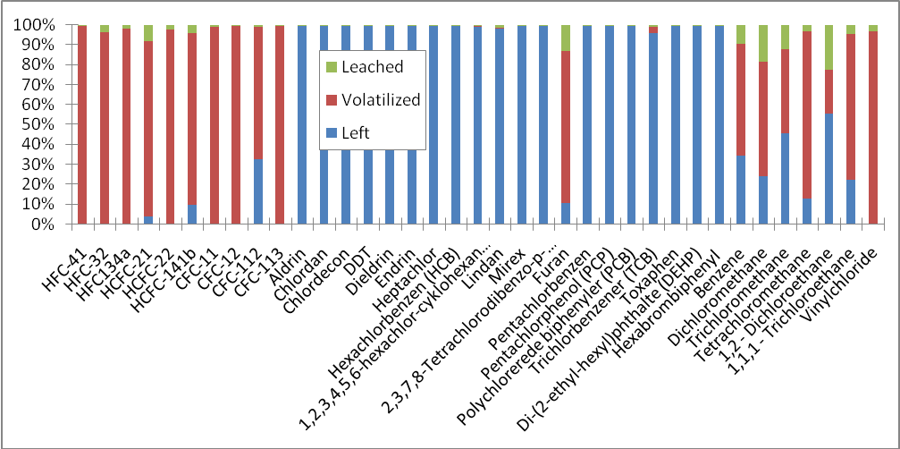
Figure 1. The distribution of pollutants in a landfill 5 years after disposal calculated by the phase distribution model MOCLA (Kjeldsen and Christensen, 2001). In the scenario is assumed that the pollutants are released instantaneously from their sources and are not degraded.
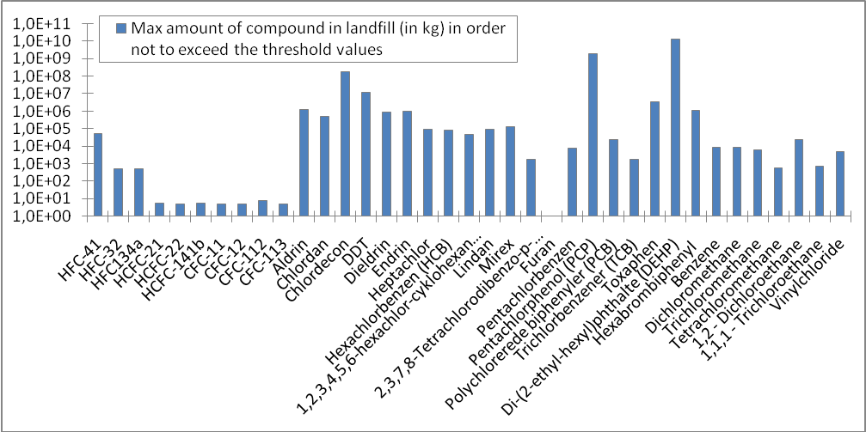
Figure 2. The maximum amount (in kg) of a pollutant in a landfill in order not to exceed the threshold values for emission to air give by the PRTR. The calculation are based the amount emitted (volatilized) as shown in Figure 1.
ACKNOWLEDGEMENT
We would like to thank Heijo Scharff for making the Afvalzorg model as well as Dutch landfill data (courtesy of the Dutch Waste Management Association) available to this project, and also for participating in discussions on the challenges of landfill operators in reporting of their emissions to the PRTR.
REFERENCES
Allen, M.R., Braithwaite A., Hills, C.C. (1997) Trace organic compounds in landfill gas at seven U.K. waste disposal sites. Environ. Sci. Technol. 31, 1054-1061.
Brosseau, J., Heitz, M. (1994) Trace gas compound emissions from municipal landfill sanitary sites. Atmos. Environ. 28, 285-293.
CEC (2006a) REGULATION (No. 166/2006) of the European Parliament and of the Council of 18 January 2006 concerning the establishment of a European Pollutant Release and Transfer Register and amending Council Directives 91/689/EEC and 96/61/EC, 4 February 2006, Brussels, Belgium.
CEC (2006b) Guidance document for the implementation of the European Pollutant Release and Transfer Registers, 31 May 2006, Brussels, Belgium.
Chanton, J.P., Powelsen, D.K., Green, R.B. (2009) Methane oxidation in landfill cover soils, is a 10% default value reasonable? J. Environ. Qual. 38, 654-663.
Danish Energy Agency (DEA) 2001. Denmark's Greenhouse Gas Projections until 2012. 64 pp. (Author: Jørgen Fenhann, Risø National Laboratory).
Eklund, B., Anderson, E.P., Walker, B.L., Burrows, D.B. (1998) Characterization of landfill gas composition at the fresh kills municipal solid-waste landfill. Environ. Sci. Technol. 32, 2233-2237.
Galle, B., Samuelsson, J., Svensson, B., Borjesson, G. (2001) Measurements of CH4 emissions from landfills using a time correlation tracer method based on FTIR absorption spectroscopy. Environ. Sci. Technol. 35 (1), 21-25.
Jacobs, J., Scharff, H. (2007) Consequences of the European Pollutants Release and Transfer Registers for Dutch landfills. In: Proceedings of Sardinia 2007, Eleventh International Waste Management and Landfill Symposium, S. Margherita di Pula, Cagliari, Italy; 1 - 5 October 2007. CD-Rom.
Kjeldsen, P., Christensen, T.H. (2001) A simple model for the distribution and fate of organic chemicals in a landfill: MOCLA. Waste Manage. & Res. 19, 201-216.
Rettenberger, G.; Stegmann, R. Landfill gas components. In: Landfilling of Waste: Biogas; Christensen, T.H.; Cossu, R.; Stegmann, R., Eds.; E & FN Spon: London, GB, 1996; pp. 51-58.
Scharff, H., Jacobs, J. (2006) Applying guidance for methane emission estimates for landfills, Waste Manage. 26 (4), 417-429.
Scheutz, C., Kjeldsen, P. (2009) Metoder til opgøresle af emissioner fra danske deponeringsanlæg til brug for PRTR-indrapportering. Miljøstyrelsen. In Danish.
Scheutz, C., Kjeldsen, P., Bogner, J., De Visscher, A., Gebert, J., Hilger, H., Huber-Humer, M., Spokas, K. (2009) Microbial methane oxidation processes and technologies for mitigation of landfill gas emissions. Waste Manage. & Res. In press, available online. DOI: 10.1177/0734242X09339325.

